How to Delete Outlook OST File

**\*Please close Outlook if you have it open before following these steps.**

1. In Citrix, click on the ^ on the bottom-right close by the date and time. If you have the Jabber icon, right-click it and click Exit Cisco Jabber

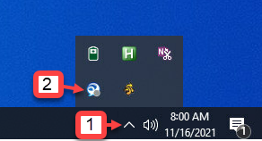

2. Click on the Start Menu (Windows Icon) on the bottom-left then click on Documents

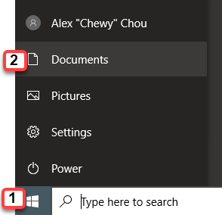

3. Copy, then paste the following into the address bar on top and hit the Enter key

%localappdata%\microsoft\outlook

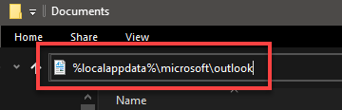

4. Highlight the Outlook Data Files and right-click on one of them, then click Delete

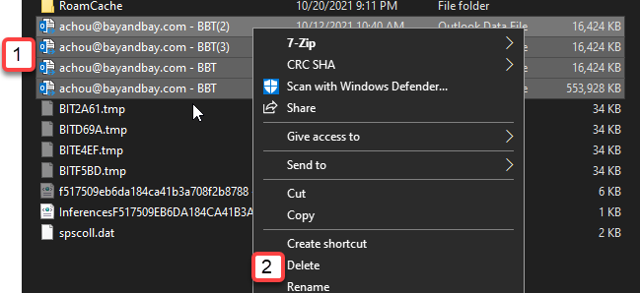

5. Your emails will download from scratch. This might take a while, but they will be up to date.